**Software Detailed Design**

**Report #4**

**Team Name:**

Mathematical Maestros

**Team Members:**

Jonathan Hasty

Jacob Coomes

Matthew Branstetter

Software Detailed Design

1. Data Design (Jonathan Hasty)

The data is stored in a relational database using SQLAlchemy. The fields for transmitting to and from the database are given in the following table.

| Attribute Name | Attribute Type | Attribute Size |
| --- | --- | --- |
| username | String | 16 |
| hashpassword | String | 80 |
| email | String | 30 |
| userid | Int | default |
| songid | Int | default |
| rating | Int | 5 |
| Id | Int | default |
| location | Int | 300 |
| emotion | String | 30 |
| steps | Int | 50 |
| AverageRating | Int | 5 |
| NumberRatings | Int | large |
| SumRatings | Int | large |

1. Architecture Design (Jonathan Hasty)

The software architecture is a client-server architecture composed of a React.js front end (client) and Python-Flask backend (server). The Flask backend will communicate with an SQLAlchemy database and fetch/serve data between the front end through REST api calls.

1. Interface Design (Jacob Coomes)

The first thing that happens when opening the website will be a sign-up/ login page. After the user sign-in they will be directed to the main page that will let the user ask the computer to create a computerized music that can be played, and if they like it they will be able to download it. The user will have to go to the bottom of the page to fill out a form that will help the computer know what type of music to make.

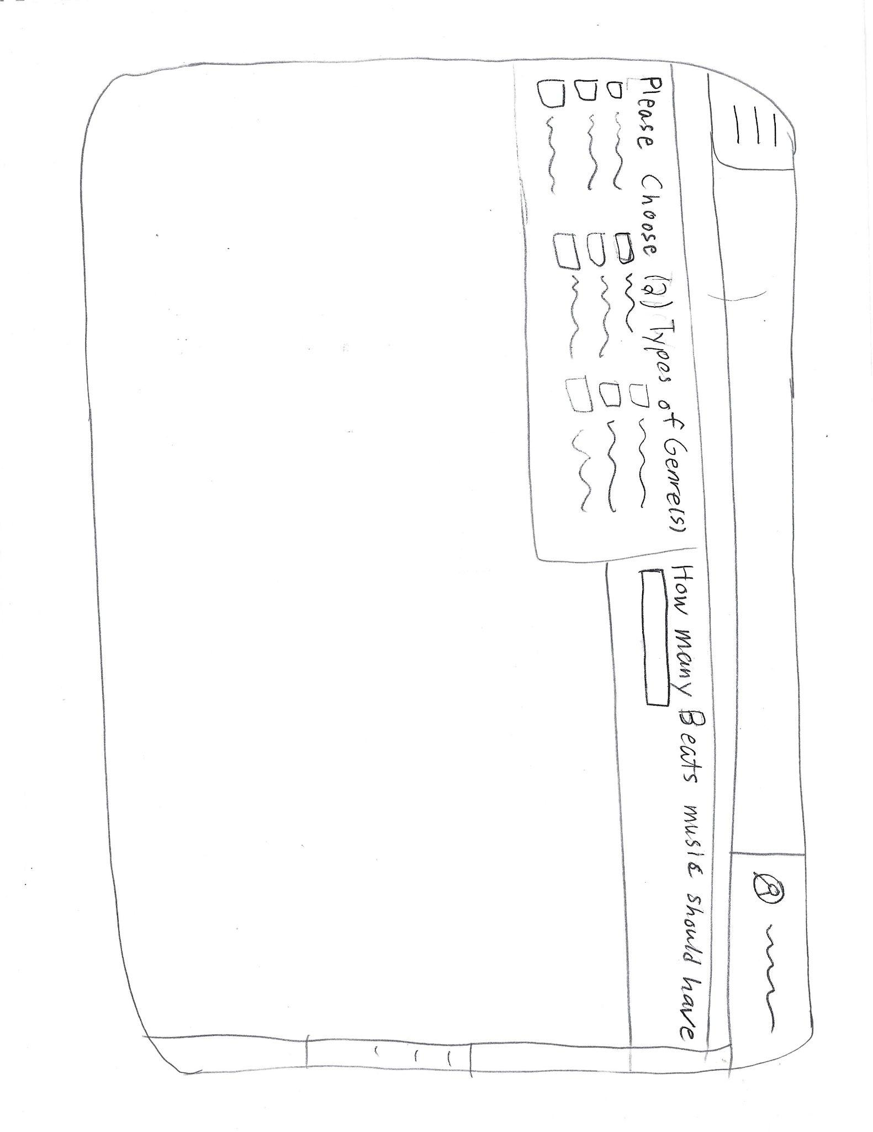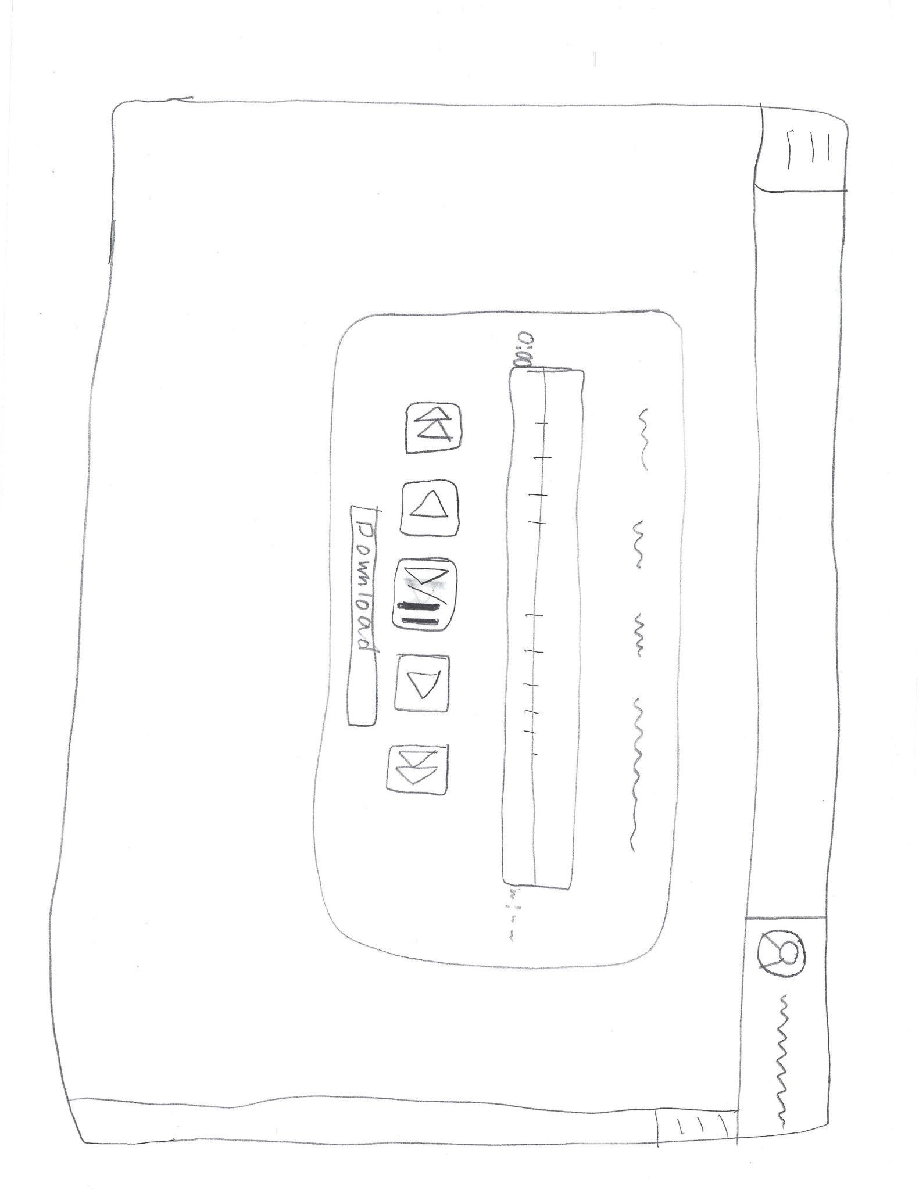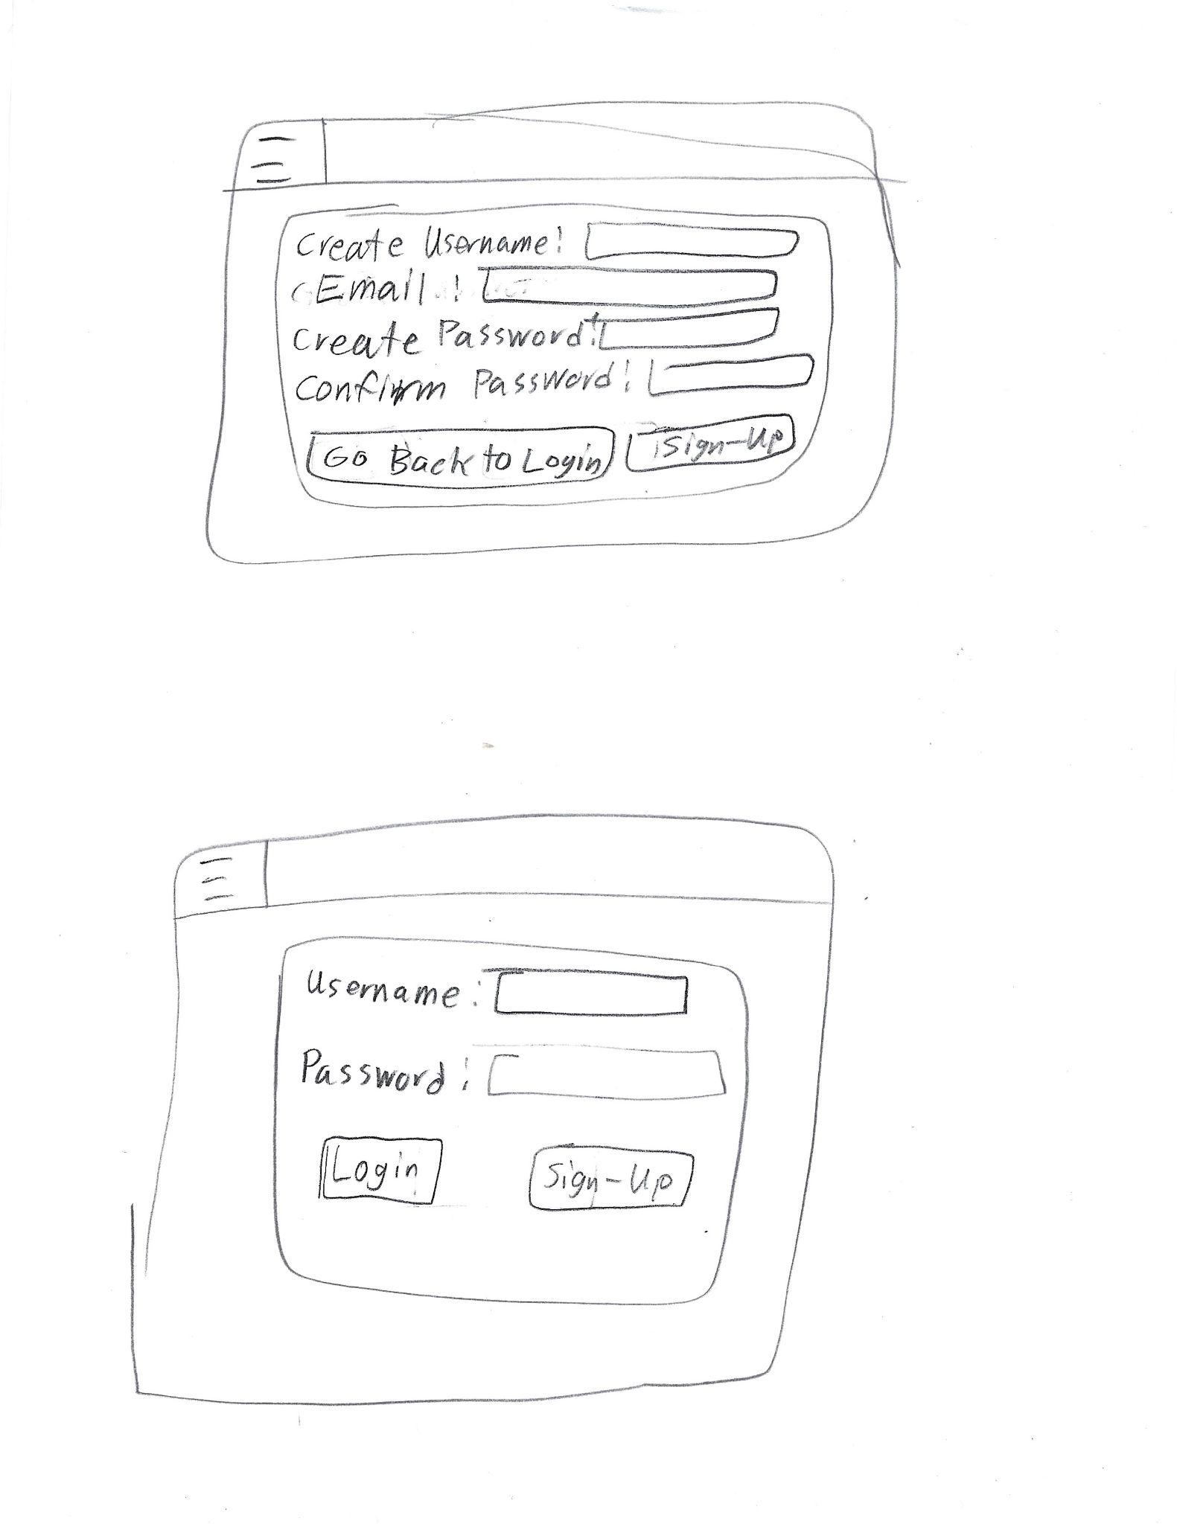

1. Procedural Design (Matthew Branstetter)

The user will first be greeted by a login screen asking for username and password before they can interact with the system. An SQL database will be queried for the username and password to let the user access the system if the input matches the data. Once inside, the user selects the mood of music-among other possible options made available-which will be predetermined buttons. After selecting the option(s) for the music to be generated the user will press a button to submit this information for music to be generated. With the options selected, the system will generate music with previous data/knowledge via machine learning to generate music for the user. Music will be created on a server and stored there as well. The path to the music will be saved to the SQL database and as such the music will be streamed from the server to the client for listening. If the user so pleases, they can download the music file from the server to their machine for listening later offline.

Data flow diagram for basic user login

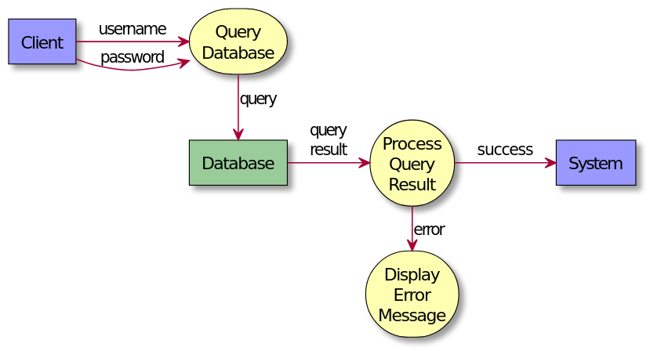

Data flow diagram for music generation and streaming

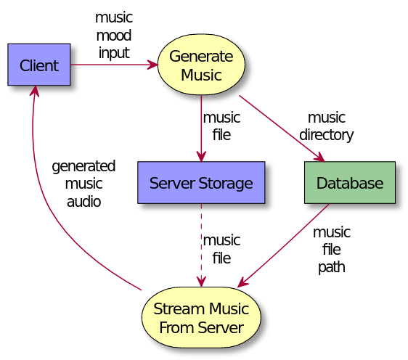

**Breakdown of individual contributions**

*(subject to change over course of project)*

Jonathan Hasty

1. Team lead

2. Documentation

3. Coding

Jacob Coomes

1. Coding

2. Documentation

3. Testing

Matthew Branstetter

1. Coding

2. Documentation

3. Testing

[**https://www.slideshare.net/peny_mg/sdd-software-des-sample**](https://www.slideshare.net/peny_mg/sdd-software-des-sample)

**Jacob Coomes**

**6012 Heil Rd. Email: coomes.jacob@yahoo.com**

**Henryville, IN 47126 Phone: 812-252-9284**

**Objective:**

**Obtain position at SamTech as programmer**

**Employment History:**

**• Short Order Cook Dairy Queen**

**Sellersburg, IN**

**8/16/16-1/31/17**

**o Duties:**

**Utilize Grill and Deep Fryer to cook various types of food**

**Take the trash out**

**Clean up work area**

**• Wholesale Employee Walnut Ridge**

**Jeffersonville, IN 4/18/17-Present**

**o Duties**

**Water Plants**

**Put Merchandise in Customer’s Cars**

**Take out trash**

**Clean and weeded the Outside area**

**Landscape Assistance**

**Education:**

**Henryville High School**

**• Address: 213 N Ferguson St, Henryville, IN 47126**

**• 12th Grade**

**o Prossor:**

**o Computer Programming**

**HTML5**

**Visual Basic 6**

**Visual Basic 2010**

**Javascript**

**Indiana University Southeast**

**• Address: 4201 Grant Line Rd, New Albany, IN 47150**

**• Major: Bachelor Degree in Computer Science**

**• Minor: Math**

**• August 24, 2017 – Present Currently Junior**

**• Computer Programming**

**o F#**

**o C++**

**o Java**

**o Assembly Language**

**• General Education**

**o Calculus 1 & 2**

**o Speech**

**o Art**

**Academic Honors:**

**• Henryville High School National Honor Society**

**• Henryville High School Technical Diploma**

**Academic Scholarships:**

**• Henryville High School Key Club Award**

**• Orrin E Weber Special Effort Award**

**• The Terry Hill Higher Education Award**

**• Willis Drake Helping Hands Award**

**Volunteer Work**

**• Saint Francis Xavier Church**

**o Fish Fry**

**o Cleaning/ Maintenance**

**o Live Nativity**

**o Septemberfest**

**o Usher**

**o Halloween Trunk or Treat**

**Traits**

**• Hard-Working**

**• Focused**

**• Organized**

**• Trustworthy**